## Installing the ToolBar

The installation requires the .NET 4.0 Framework to be installed on the machine.

1. Run the setup.exe as Administrator
2. Accept all defaults
3. After the Installation runs a batch file will run to register all the components
   1. You should Receive a popup for “Registration Succeeded”
   2. You should Receive a popup for “Installation Succeeded”
4. Open ArcMap
5. Open the CUSTOMIZE 🡪 Extensions Menu Item
   1. Make Sure the iFormBuilder Tools Extension is checked

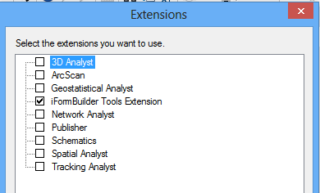

### Configuring ArcMap to use the .NET 4.0 Framework

If the tool is not showing in the extenstion manager you will need to edit the ArcMap.exe.config file to allow ArcMap to use the .NET 4.0 Framework.

1. Naviagate to C:\Program Files (x86)\ArcGIS\<VERSION>\bin
2. Open the ArcMap.exe.config file (this has to be as an administrator)
3. In the startup section change the supportedRuntime tag

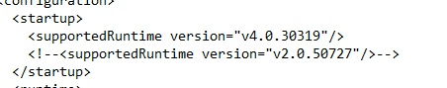

## The iFormBuilder toolbar

This addin toolbar is designed to manage the interactions between ArcGIS and iFormBuilder.



### Download iFormDataTable



1. Click the Download Button

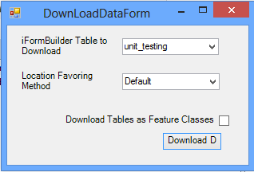

1. Select the Table you wish to download from iFormBuilder
2. Select the Location method
   1. Default (Best location will be determined)
   2. Location Widget (Information from a Location Widget will be favored)
   3. Modified Location (The Modified Location will be the favored location)
   4. Created Location (The Created Location will be favored)
3. Download Tables as Feature Classes
   1. Checked: All Subforms will be downloaded at Feature Classes
   2. Unchecked: All Subforms will be downloaded as Tables
      1. Note: A relationship class between the parent and the child will be created for both methods

### Synchornize iFormDataTable



1. Click the Synchorize Button
   1. The tool will run for each separate workspace you have in the map

### Cofingure iFormDataTable



1. Opens the Configuration Window

